**4.6 I can assess when there is a problem with collaborative technologies and when to get expert help**

I recently tried to download Microsoft teams on my laptop. I was able to download and open the application however it kept buffering, crashing my laptop or causing the browser to ‘hang’. I had noticed that my laptop was very slow to use when using the browser and would crash or refuse to close. When using the task manager to force my browser to close I noticed that the computer had a very high CPU and was ruining consistently at 99%. My first thought was that I possibly had a virus on my laptop so I ran an anti-virus scan using Microsoft windows however no issues were found.

I decided to use google to search for possible solutions to resolve the issue. Several websites including Microsoft Windows user forums mentioned that a possible cause could be an issue with the WMI Provider Host service. I followed a step by step process on listed the website <https://geekdroids.com/wmi-provider-host/> as the instructions were clear and the website is well established and I therefore felt I could trust it.

An example of following the steps outlined on the above website;

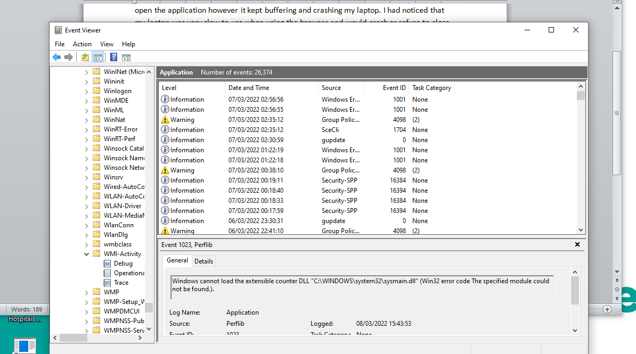

I completed the steps in full from the website linked to above and this did help to resolve the issue with a high CPU usage on my computer. Generally when I have an issue with an application or with hardware I will research the issue on google for advice from websites and forums such as Microsoft Community.